Tab 1

Vision & Scope Document
ComiVerse-A Digital Comic Platform with Integrated Translation and Content Distribution Tools
(CVP) - Report 1

Project Name | ComiVerse
Version | v1.1.0
Date Created | 20/5/2026
Last Updated | 12/8/2026
Authors | Bùi Quang Hiệp - HE171337  Bùi Việt Hùng - HE163146  Chu Tuấn Ngọc - HE186006  Nguyễn Xuân Hanh - HE180944  Đặng Ngọc Thành - HE186611
Reviewer | Lê Thị Tú Kiên - Instructor
Status | Approved

Document Change History
Version | Date | Changes | Author
v1.0.0 | 20/05/2026 | Initial creation of the Vision & Scope Document including product background, existing solution analysis, and proposed solution overview. | All members
v1.0.0 | 21/05/2026 | Added Existing Solutions analysis, completed Proposed Solution section, and expanded Major Features and Limitations content. | All members
v1.0.0 | 28/05/2026 | Refined GAP definitions into structured GAP IDs, updated feature-to-gap mappings, improved offline reading security description, revised document formatting, and finalized Report 1 content. | All members
v1.0.0 | 31/05/2026 | Fixed Section 4 – Major Solution. Updated Product Background and added supporting references/sources. | Chu Tuấn Ngọc  Bùi Việt Hùng
v1.1.0 | 12/08/2026 | Update layout and reference , product proposed solution | Bùi Quang Hiệp

1. Product Background
Comic publishers, copyright studios, and translation groups (scanlation teams) in Vietnam currently manage their localization and production pipelines through a highly fragmented ecosystem of standalone tools, such as Adobe Photoshop, Discord, Google Docs, and disparate cloud storage drives. A typical translation team leader spends an average of 4–5 hours per day executing manual administrative tasks: extracting raw images, distributing individual comic pages to team members via chat applications, and cross-checking terminology across unoptimized spreadsheets. During new title launches or peak release periods, this decentralized workflow becomes a severe bottleneck. Text bubbles are misplaced, translation continuity is disrupted across chapters, and the final localized releases suffer from delays spanning hours or even days.

This operational friction introduces a critical latency, paving the way for unauthorized aggregator websites (e.g., NetTruyen and its clones) to scrape proprietary content and hijack massive reader traffic using automated crawlers. According to recent data from MUSO and Similarweb, traffic to unauthorized comic websites in Vietnam is currently 29 times higher than that of legitimate platforms. The failure to streamline the translation and publishing workflow costs the local digital content industry an estimated $350 million annually, with over 15.5 million active readers lost to piracy (MPA, 2026). Readers abandon official platforms not primarily due to monetization models, but because they refuse to tolerate the prolonged release schedules caused by these disjointed, manual operations.

The urgency for a centralized technological solution has never been more apparent. Following the Vietnamese government's recent issuance of Directive No. 38/CĐ-TTg (May 2026), which mandates an aggressive crackdown on high-traffic piracy websites, millions of readers are initiating a massive migration back to legitimate platforms. If official publishers and studios do not immediately adopt a centralized collaborative workspace to facilitate Simultaneous Publishing (Simulpub), their current manual pipelines will be entirely overwhelmed. Consequently, they risk missing an unprecedented opportunity to capture and retain this returning user base. The industry urgently requires a comprehensive system that strictly protects intellectual property while providing a seamless, integrated workspace for translation communities, enabling them to outpace unauthorized distributors in both speed and quality.

2. Existing Solutions

2.1 MangaDex
MangaDex is an open-source, community-driven online manga reading platform that allows global scanlation groups to translate and upload chapters directly to the system. It operates as a non-profit platform focusing on community collaboration and multi-language support.

Attribute | Description
Website / Link | https://mangadex.org
Target Users | Global manga readers, independent translation groups, and community moderators.
Core Features | Read manga online, multi-language chapter uploads, translation group management, follow/bookmark features, advanced search/filter, and reading history tracking.
Strengths | User-friendly and ad-free interface; robust role-based access control for translators; extensive support for multiple languages; fast image loading speed via dedicated CDN.
Weaknesses | UI can be complex and overwhelming for beginners; frequent missing/incomplete chapters due to reliance on voluntary user uploads; search functionality is occasionally unoptimized.
GAP for this project | GAP-01: Lacks localization features tailored specifically to a streamlined, fast-paced local market (e.g., Vietnam)  GAP-02: Does not support automated content aggregation.  GAP-03: Does not support monetization models for premium creators/publishers.
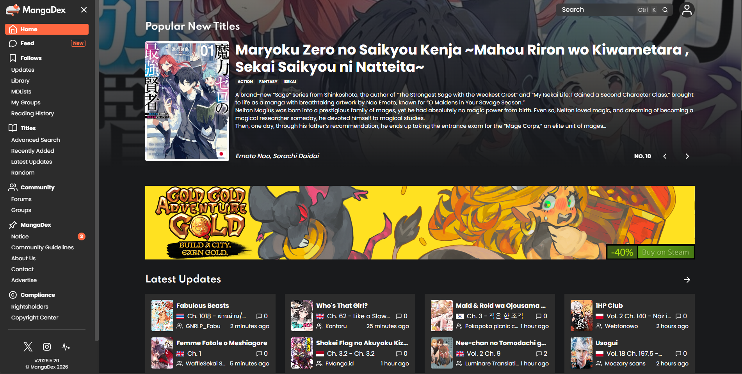
Figure 1.1 - Mangadex Hompage

2.2 Webtoon
Webtoon is a major commercial online comic platform owned by Naver, focusing primarily on vertical-scrolling webtoons optimized for mobile devices. It serves as an official publishing platform for both professional creators and independent artists through its Canvas program.

Attribute | Description
Website / Link | https://www.webtoons.com
Target Users | Mobile-centric comic readers, professional digital artists, and independent comic creators.
Core Features | Vertical-scroll reading interface, account registration, push notifications for new chapters, user rating/comment system, and an AI-driven story recommendation engine.
Strengths | Beautiful, modern, and highly responsive mobile UI; excellent user experience; powerful recommendation system that boosts user engagement.
Weaknesses | Very limited support for custom or fan-made translation group uploads; major content is locked behind paywalls (Fast Pass system); strict platform-controlled publishing guidelines.
GAP for this project | GAP-04: Operates as a closed, highly regulated ecosystem that prohibits community-driven translations.  GAP-05: Prohibits standard horizontal manga formats.  GAP-06: Cannot serve as an open platform where diverse local translation groups or community admins can freely manage and curate external content.

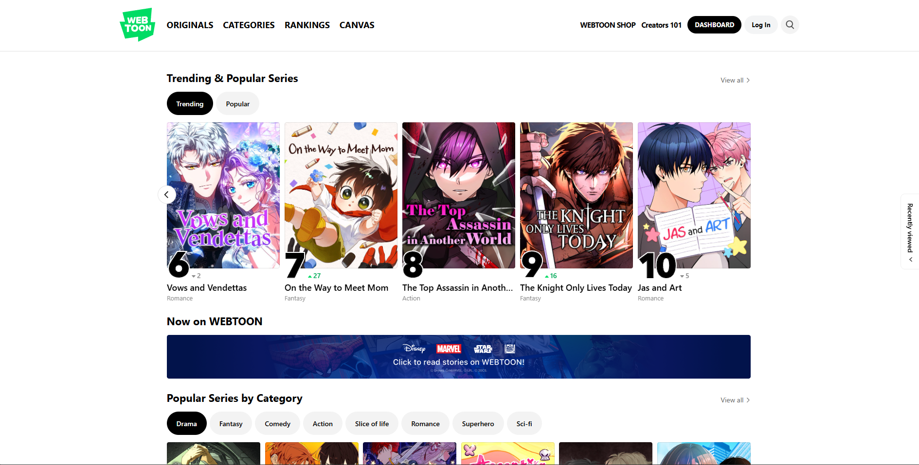
Figure 1.2 - WebToon Homepage

2.3 NetTruyen
NetTruyen is one of the most popular comic-reading websites in Vietnam, featuring a massive library of aggregated manga and webtoon titles with rapid update speeds targeted at local audiences.

Attribute | Description
Website / Link | https://nettruyenww.com
Target Users | Vietnamese comic and manga readers looking for free content.
Core Features | Free comic reading, basic keyword search, user comments, story ratings/rankings, and reading history tracking.
Strengths | Extremely massive library of titles; incredibly fast update speeds; tailored perfectly to the reading habits and language preferences of Vietnamese users.
Weaknesses | Heavy and intrusive ad presence (pop-ups, banners) that ruins user experience; outdated and unappealing UI; suboptimal content management with no proper permissions for original translators.
GAP for this project | GAP-07: Suffers from a poor user experience due to excessive advertising.  GAP-08: Features a legacy interface.  GAP-09: Lacks role-based access control for legitimate translation groups to manage their own work.  GAP-10: Misses the balance between community contribution and a clean, modern user experience.

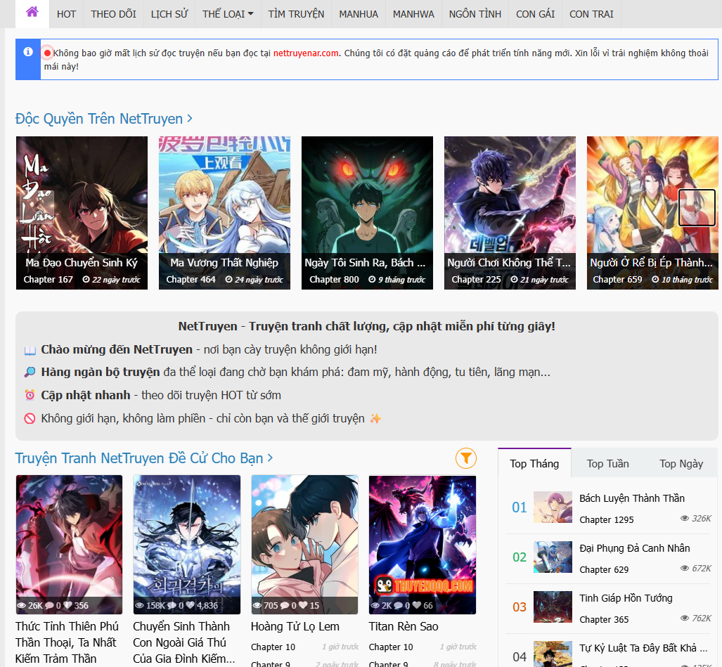

Figure 1.3 - Mangadex Hompage

3. Proposed Solution
This product serves as a centralized, controlled ecosystem that simultaneously solves the issues of content fragmentation, legal vulnerabilities, and poor quality control in the digital comic space. By establishing a unified environment where authors retain structural control over their intellectual property—allowing them to either open projects to community localization or trigger platform-managed translation—the platform closes the critical gaps of unprotected author copyrights and unregulated, low-quality "wild west" fansubbing. It eliminates the friction of multi-platform coordination by bringing creators, translators, and readers under one roof with built-in oversight.
The primary beneficiaries are creators, localization teams, and the readers themselves. Authors benefit from a secure, flexible distribution network where they can safely monetize their work internationally without losing control over their intellectual property or dealing with third-party hiring logistics. Fansub groups and professional translators gain a standardized, authenticated space to showcase their skills, access legitimate source material, and participate in clear revenue-sharing models. Ultimately, readers benefit from a seamless, high-quality reading experience, free from the disjointed translations and security risks of pirate websites.
This approach is uniquely timed for the current market because the global demand for digital comics and webtoons has reached an all-time high, yet the translation pipeline remains heavily fractured between high-cost traditional publishing and illegal scanlation networks. Relying solely on open crowdsourcing compromises quality and legal safety, while traditional corporate localization is too slow and selective for independent creators. By acting as an institutional broker that actively manages the distribution framework and tailors the localization path to each comic's legal requirements, this platform provides the exact balance of scalability, security, and quality control needed to modernize digital comic distribution.
Furthermore, the platform's architecture is engineered for high performance and modern user experiences. By leveraging Redis caching for high-frequency engagement metrics (views, likes, ratings, bookmarks), the system ensures minimal database bottlenecks and high availability. The integration of AI OCR for automated text extraction, a dedicated Glossary System, and WebSocket-based Real-time Team Chat (STOMP) dramatically accelerates the localization workflow. User accessibility and engagement are further enhanced through Google OAuth 2.0 login, Vector-based AI content recommendations, and a strictly controlled Offline Download feature, perfectly balancing reader convenience with copyright protection.
For readers, the system delivers a clean, ad-free reading experience, highlighted by the "Dynamic Translation Switching" feature that allows them to seamlessly swap translation versions directly within the viewer if a title is localized by multiple scanlation teams. The deeply integrated Discussion Forum further enables users to easily connect, debate, and cultivate a civilized fan community. For translators, the system provides an advanced administration panel to track readership metrics and engagement levels, along with a built-in Digital Wallet system that allows them to directly manage and withdraw revenue generated from premium content (via a point/coin-based chapter unlocking mechanism) or direct donations from their fanbase.

4. Project Scope & Limitations

4.1 Major Features
ID | Feature Name | Description | Addresses Gap
FE-01 | Comic Reading System | Provides comprehensive functionalities that leverage behavioral analytics and preferences to deliver personalized comic recommendations using a Vector-based AI Recommendation System. It delivers an optimized reading experience featuring multi-mode viewing, progress synchronization, dynamic multi-translation switching, and smart tracking tools. Additionally, it supports an Offline Download feature with strict download limits to balance user convenience and bandwidth protection. | GAP-01, GAP-06, GAP-09
FE-02 | Translation Management | Provides an online collaborative workspace for translators to localize and edit comic chapters. It integrates AI OCR (Optical Character Recognition) technology to automatically detect and extract text from raw comic images, significantly accelerating the localization process. | GAP-01, GAP-06, GAP-09
FE-03 | Translation Project Team Member Management | Provides the organizational infrastructure for initialization, profile customization, and membership governance of localization collectives. It features a Glossary System, allowing each Project Team to build and maintain an internal dictionary to ensure terminology consistency across chapters. It incorporates an agile task management engine to decompose chapter production into specific pipelines.
FE-04 | Comic Management | The author can upload comics and send them to the moderator. The moderator can approve to publish, reject and also delete it. Allows users to rate and comment on individual chapters or entire comics, supporting community discussions, feedback, and interactions between readers, authors, and translation groups.
FE-05 | Forum & Real-time Chat System | Provides community discussion spaces for reviews, theories, spoilers, and reader interactions. To enhance internal collaboration, it features a Team Chat integrated via STOMP over WebSocket, enabling real-time messaging and seamless communication among translation team members. | GAP-10
FE-06 | Notification & Compliance Audit Core | Automatically sends notifications regarding new chapters, translation updates, comment replies, moderation actions, and system announcements .Allows moderators and administrators to process reports, hide violating content, suspend accounts, and enforce platform policies.
FE-07 | Payment Management | Supports premium chapter unlocking, transaction management, and monetization mechanisms for users and creators.
FE-08 | Comic Statistic | Provides dashboards and analytical statistics for monitoring platform activities. System performance is highly optimized using Redis; high-frequency engagement metrics (views, likes, ratings, and saves) are temporarily cached and processed in Redis rather than being written directly to the database, ensuring high availability during traffic spikes.
FE-09 | Platform Management Subsystem | Allows administrators to manage system configurations, user permissions, feature toggles, platform settings, and operational maintenance tasks.
FE-10 | User Management Subsystem | Provides the core administrative and security capabilities required to manage user registration, authentication, and data access. It supports seamless and secure user onboarding through Google OAuth 2.0 integration, enhancing login convenience while maintaining strict access controls.

4.2 Limitations & Exclusions

ID | Excluded Item | Reason
LI-01 | Direct Bank API and Payment Gateway Integration | Direct integration with local commercial bank APIs or third-party payment gateways (e.g., Napas, VNPAY) involves complex legal compliance, security certifications, and financial overhead. Version 1 records payment status and handles virtual wallet balances internally, utilizing a manual admin-approved QR code mechanism to verify transactions safely.
LI-02 | Multi-Platform Native Applications | Developing and maintaining native applications across multiple operating systems simultaneously dilutes development resources during a limited project timeline. Version 1 focuses on a robust, responsive web application and an Android mobile package (APK) to validate core user workflows before scaling to other ecosystems.
LI-03 | Dynamic Video/Audio Layer Integration for Motion Webtoons | Rendering heavy multimedia layers drastically decreases page loading speed and degrades the user experience on low-end mobile devices or unstable local networks. Processing static image formats (JPEG, PNG, WebP) guarantees optimal system performance and lower bandwidth consumption.
LI-04 | Sub-chapter/Page-level Task Assignment | In this current version, the task management engine only supports assigning a specific localization pipeline step to a single member per chapter. The system does not yet support splitting a single task by page ranges (e.g., assigning pages 1-5 to User A and pages 6-10 to User B). This limitation helps maintain architectural simplicity and prevents complex concurrency conflicts during the initial launch phase.

5. Expected Contributions & Next Steps

5.1 Business & Operational Impact

By combining licensed comic distribution, translator management, and community interaction into a unified platform, the system helps publishers and administrators manage content more efficiently while reducing dependence on unofficial translation websites. Centralized management improves consistency in content updates, translation workflows, and copyright control across all stories available on the platform.

By implementing a translator registration and verification mechanism, the platform reduces the time required to review translation contributors and improves overall translation quality. Trusted translation teams can be assigned to licensed stories with stricter copyright requirements, helping publishers maintain professional standards and reduce the risk of copyright violations.

By integrating forums and community discussions directly into story pages, the platform increases user engagement and encourages longer platform usage time. Increased reader activity supports future monetization opportunities such as premium memberships, advertisements, sponsored content, and partnerships with publishers.

By collecting centralized reading and interaction data, the system also supports future operational analysis, including content popularity tracking, reader behavior analysis, and personalized recommendation strategies. These insights can help platform administrators make more effective content and business decisions.

5.2 User Experience Impact

Readers benefit from a stable and legal reading environment that provides higher quality translations, more reliable chapter updates, and better reading consistency compared to unofficial comic websites. Verified translation teams help ensure that licensed stories maintain translation accuracy and professional presentation quality.

Users gain a more convenient experience by accessing reading, discussion, and community features within the same ecosystem. Dedicated forums for each story allow readers to share opinions, theories, reviews, and recommendations without relying on external social media groups or separate discussion platforms.

Translators and translation teams receive opportunities to participate in legal translation activities through a structured registration and approval process. Reputation and contribution tracking also help skilled translators gain recognition within the platform community.

Mobile users can access the platform through the existing Android application distributed via APK, allowing readers to continue following stories and community discussions more conveniently on mobile devices. Synchronization of reading history and bookmarks between devices further improves continuity and accessibility.

5.3 Planned Next Steps After Project Completion

Following the successful deployment of version 1, future development will focus on improving platform intelligence, scalability, and accessibility. The current version already includes a mobile reading application distributed through APK installation for Android users.

The next planned improvements include: AI-based recommendation systems that analyze reading behavior, favorite genres, and user interactions to provide personalized story suggestions, AI assisted moderation tools for detecting spam, inappropriate forum content, and unauthorized uploads, AI supported translation assistance features to help translators improve translation speed while maintaining human quality control, and enhanced analytics systems for administrators and publishers to monitor reader engagement and content performance.

Future expansion plans also include publishing the mobile application through official platforms such as Google Play and the App Store, adding multilingual support for international communities, and integrating digital payment systems for premium subscriptions and licensed content purchases. Additional scalability improvements may involve cloud based optimization and stronger collaboration systems between publishers and verified translation teams.

References:
- Vigorously implement Directive 38 on protecting intellectual property rights.
- From Official Dispatch 38 to the discipline of creativity in cyberspace

